

# Rossmoyne Senior High School

### Semester One Examination, 2016

### Question/Answer Booklet

# MATHEMATICS

If required by your examination administrator, please place your student identification label in this box

**METHODS**

**UNIT 1**

## Section Two:

## Calculator-assumed

|  |  |  |  |  |  |  |  |  |
| --- | --- | --- | --- | --- | --- | --- | --- | --- |
| Student Number: In figures |  |  |  |  |  |  |  |  |

In words

Your name

## Time allowed for this section

Reading time before commencing work: ten minutes

Working time for section: one hundred minutes

## Materials required/recommended for this section

***To be provided by the supervisor***

This Question/Answer Booklet

Formula Sheet (retained from Section One)

***To be provided by the candidate***

Standard items: pens (blue/black preferred), pencils (including coloured), sharpener, correction fluid/tape, eraser, ruler, highlighters

Special items: drawing instruments, templates, notes on two unfolded sheets of A4 paper, and up to three calculators approved for use in the WACE examinations

## Important note to candidates

No other items may be taken into the examination room. It is **your** responsibility to ensure that you do not have any unauthorised notes or other items of a non-personal nature in the examination room. If you have any unauthorised material with you, hand it to the supervisor **before** reading any further.

## Structure of this paper

|  |  |  |  |  |  |
| --- | --- | --- | --- | --- | --- |
| Section | Number of questions available | Number of questions to be answered | Working  time (minutes) | Marks available | Percentage of exam |
| Section One:  Calculator-free | 7 | 7 | 50 | 51 | 35 |
| Section Two:  Calculator-assumed | 13 | 13 | 100 | 98 | 65 |
|  | | | **Total** | 149 | 100 |

## Instructions to candidates

1. The rules for the conduct of examinations are detailed in the school handbook. Sitting this examination implies that you agree to abide by these rules.
2. Write your answers in this Question/Answer Booklet.
3. You must be careful to confine your response to the specific question asked and to follow any instructions that are specified to a particular question.
4. Spare pages are included at the end of this booklet. They can be used for planning your responses and/or as additional space if required to continue an answer.

* Planning: If you use the spare pages for planning, indicate this clearly at the top of the page.
* Continuing an answer: If you need to use the space to continue an answer, indicate in the original answer space where the answer is continued, i.e. give the page number. Fill in the number of the question that you are continuing to answer at the top of the page.

1. **Show all your working clearly**. Your working should be in sufficient detail to allow your answers to be checked readily and for marks to be awarded for reasoning. Incorrect answers given without supporting reasoning cannot be allocated any marks. For any question or part question worth more than two marks, valid working or justification is required to receive full marks. If you repeat any question, ensure that you cancel the answer you do not wish to have marked.
2. It is recommended that you **do not use pencil**, except in diagrams.
3. The Formula Sheet is **not** to be handed in with your Question/Answer Booklet.

Section Two: Calculator-assumed 65% (99 Marks)

This section has**thirteen (****13)** questions. Answer **all** questions. Write your answers in the spaces provided.

Working time for this section is 100 minutes.

Question 8 (6 marks)

(a) Show how to establish that the exact value of  is . (3 marks)

(b) The graphs of  and  are shown below. Determine, to the nearest degree, the size of the angle . (3 marks)

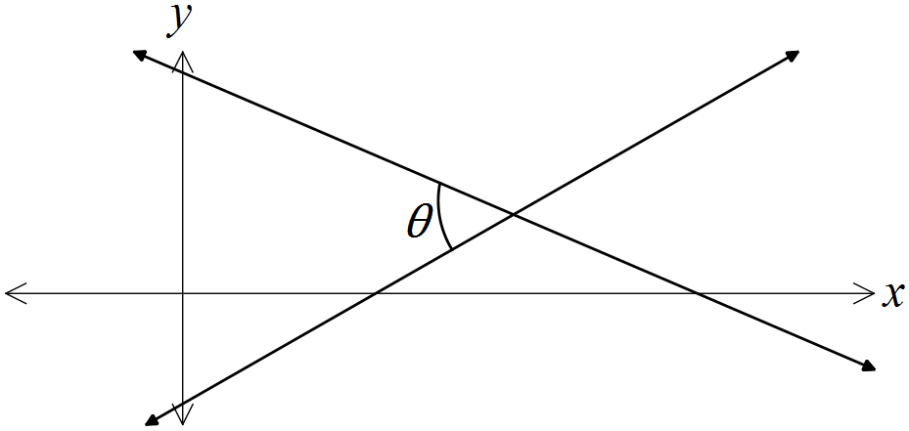

Question 9 (7 marks)

The graphs of the functions,  and  are shown below, where a, b, c, d, m and n are positive constants.

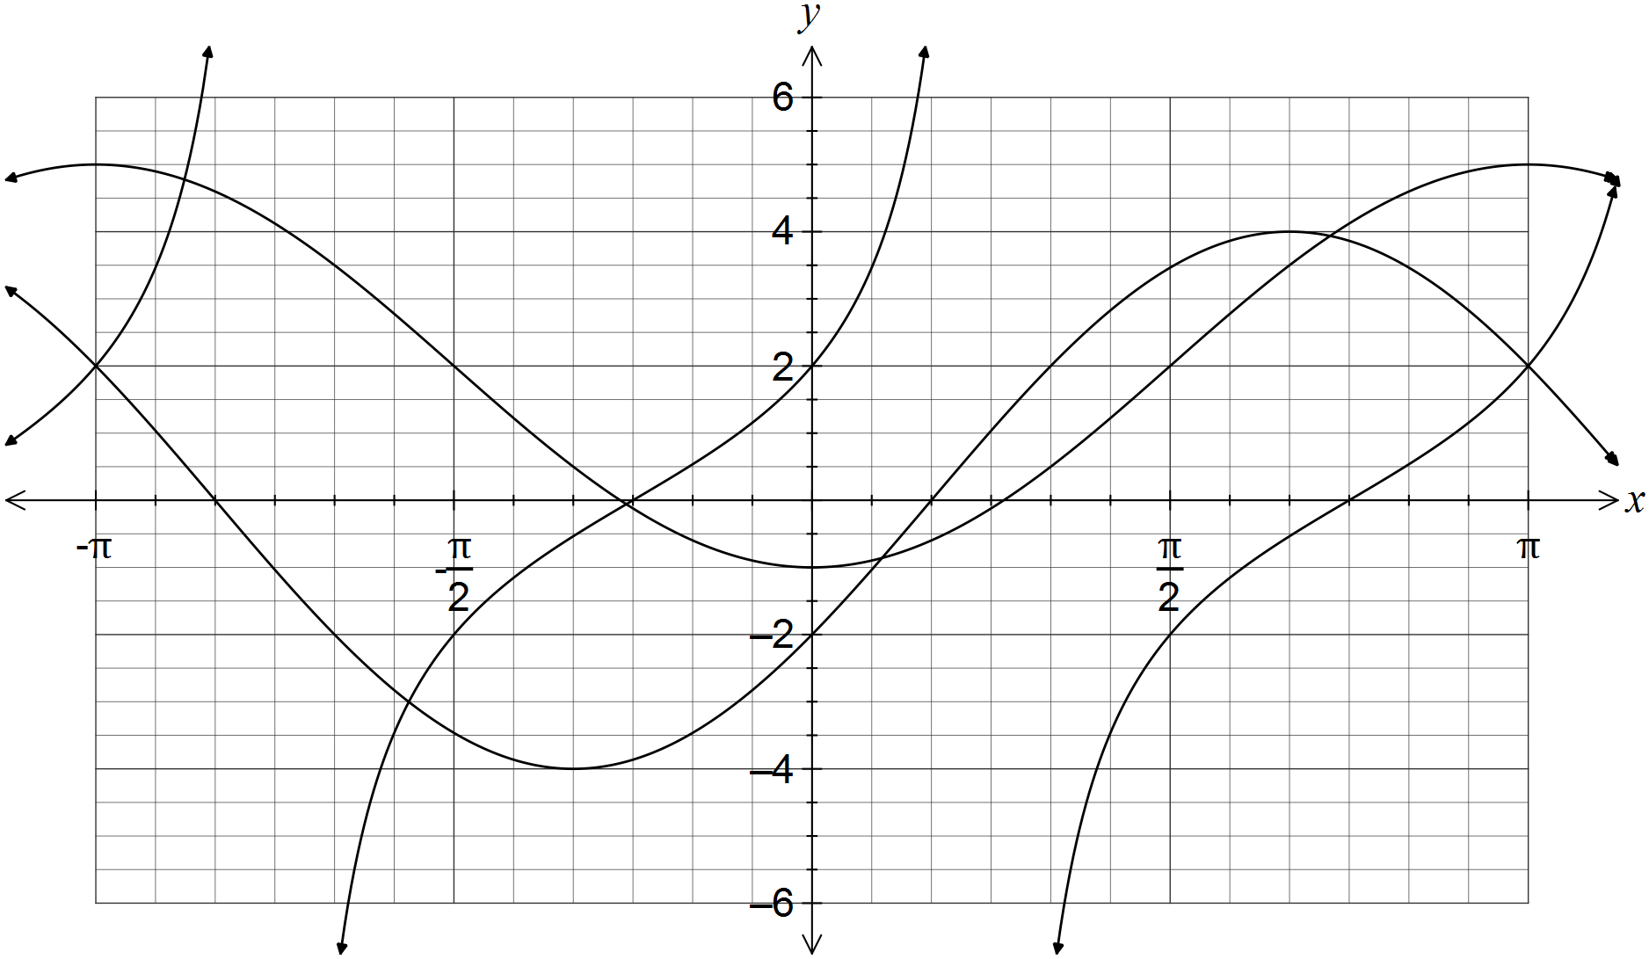

(a) Clearly label each of the functions f, g and h on the graph. (1 mark)

(b) Determine the values of the positive constants a, b, c, d, m and n. (6 marks)

Question 10 (7 marks)

(a) The extension, e, of a spring is directly proportional to the mass, m, hung on the end of it. When a mass of 100 g was hung on the spring, its extension was 25 mm.

(i) Write an equation that relates the variables e and m. (2 marks)

(ii) Determine m when  mm. (1 mark)

(b) A full water tank can be emptied in 40 minutes using a small pump and in 10 minutes using a large pump. Assuming that the pumps do not affect each other when used together, determine the time required to empty the tank using both pumps. (4 marks)

Question 11 (7 marks)

A function is defined by .

(a) State the domain of this function. (1 mark)

(b) Draw the graph of  on the axes below, clearly showing the coordinates of all axis-intercepts and equations of any asymptotes. (4 marks)

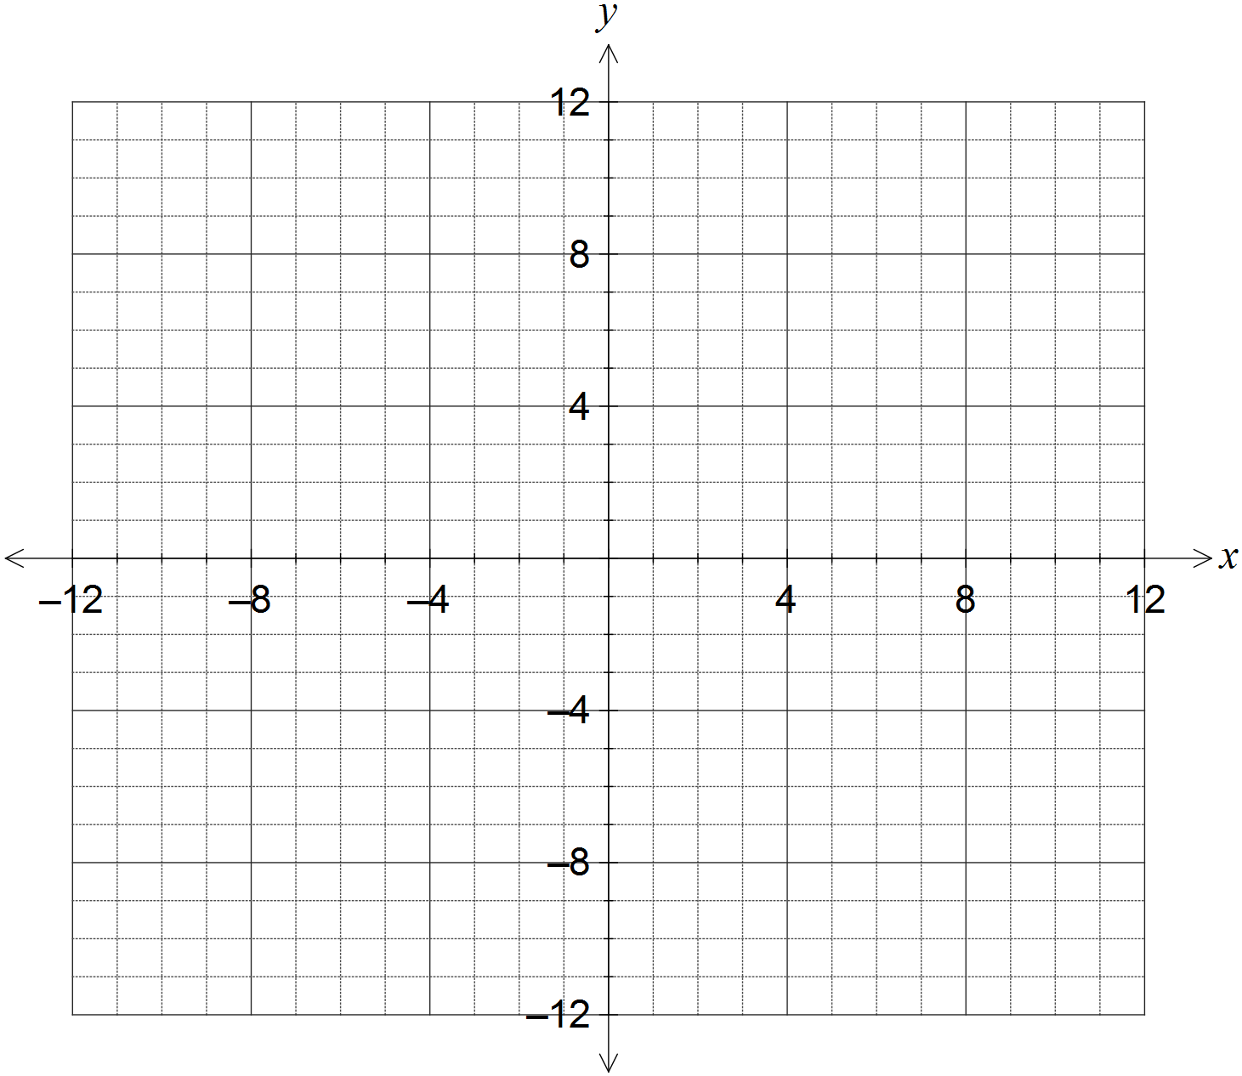

(c) The graph of  is dilated vertically by a scale factor of 4 followed by a translation of three units to the right. Determine the coordinates of the y-intercept of the transformed graph. (2 marks)

Question 12 (8 marks)

(a) A 3.6 m long ladder first rests against a vertical wall BC, making an angle of 70° with the horizontal ground. The ladder is rotated in a vertical plane about E to rest against wall AD, reaching a point 2.6 m above the ground.

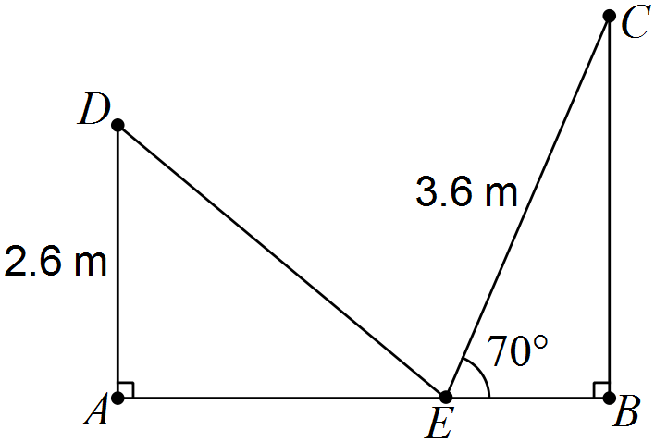

Showing use of trigonometry, determine

(i) the angle through which the ladder was rotated. (2 marks)

(ii) the distance AB. (2 marks)

(iii) the distance DC. (2 marks)

(b) A thin metal plate in the shape of an equilateral triangle has an area of 330 cm. Determine the side length of the triangle. (2 marks)

Question 13 (9 marks)

(a) A square is inscribed in a circle of radius 16 cm, as shown below. Determine the area enclosed between the square and the circle. (3 marks)

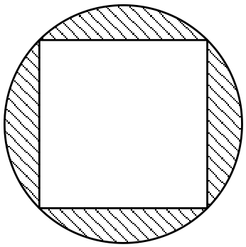

(b) The perimeter of a sector, with central angle  radians in a circle of radius r, is 12 cm.

(i) Express  in terms of r. (2 marks)

(ii) Show that the area of the sector is . (2 marks)

(iii) Determine the area of the sector if . (2 marks)

Question 14 (7 marks)

A function and a relation have been graphed on the axes below.

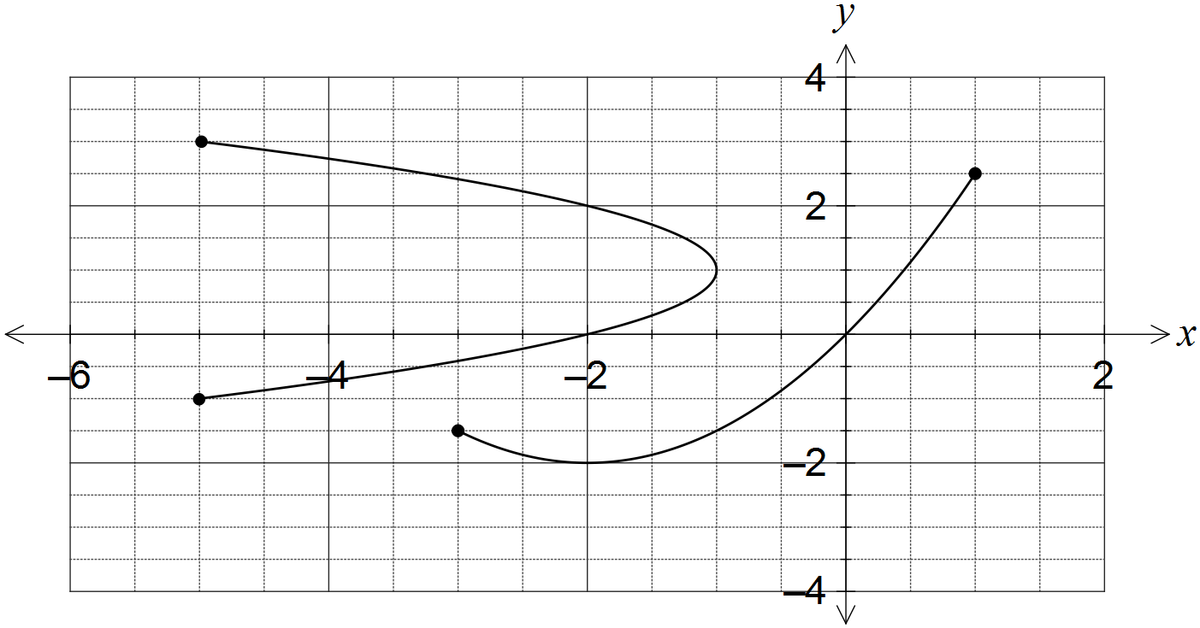

(a) Draw the line  on the graph and explain how it can be used to identify the relation. (2 marks)

(b) State the domain and range of the function. (2 marks)

(c) The relation can be expressed in the form . Determine the values of the constants a and b. (3 marks)

Question 15 (9 marks)

A sensor was fitted to the tip of a blade on a wind turbine to measure the height, h metres, of the blade above the ground. The height was observed to vary according to the function  , where  is the time in seconds since measurements began.

(a) Determine the height of the blade tip above the ground when . (1 mark)

(b) Sketch the graph of  on the axes below for . (4 marks)

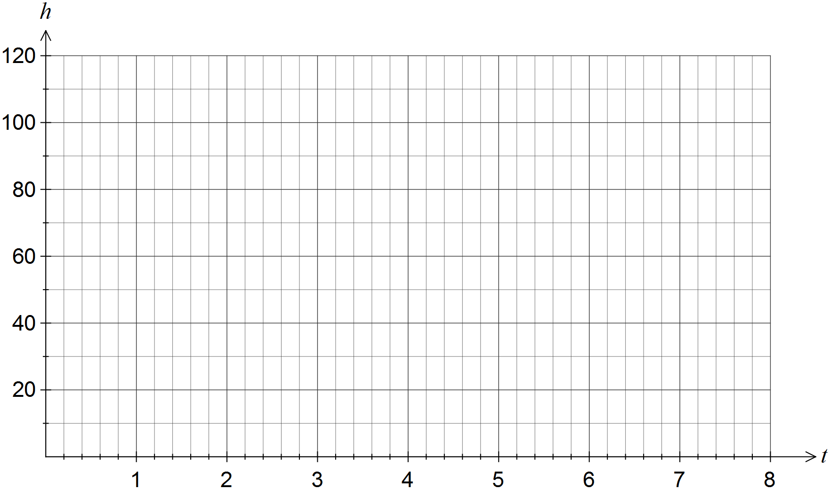

(c) How long does the blade take to rotate once? (1 mark)

(d) Assuming the blade continues to rotate in this manner, determine the percentage of time during which the blade tip is at least 90 m above the ground. (3 marks)

Question 16 (7 marks)

The graphs of ,  and  are shown below. Determine the values of the constants a, b, c, d, n, p and q.

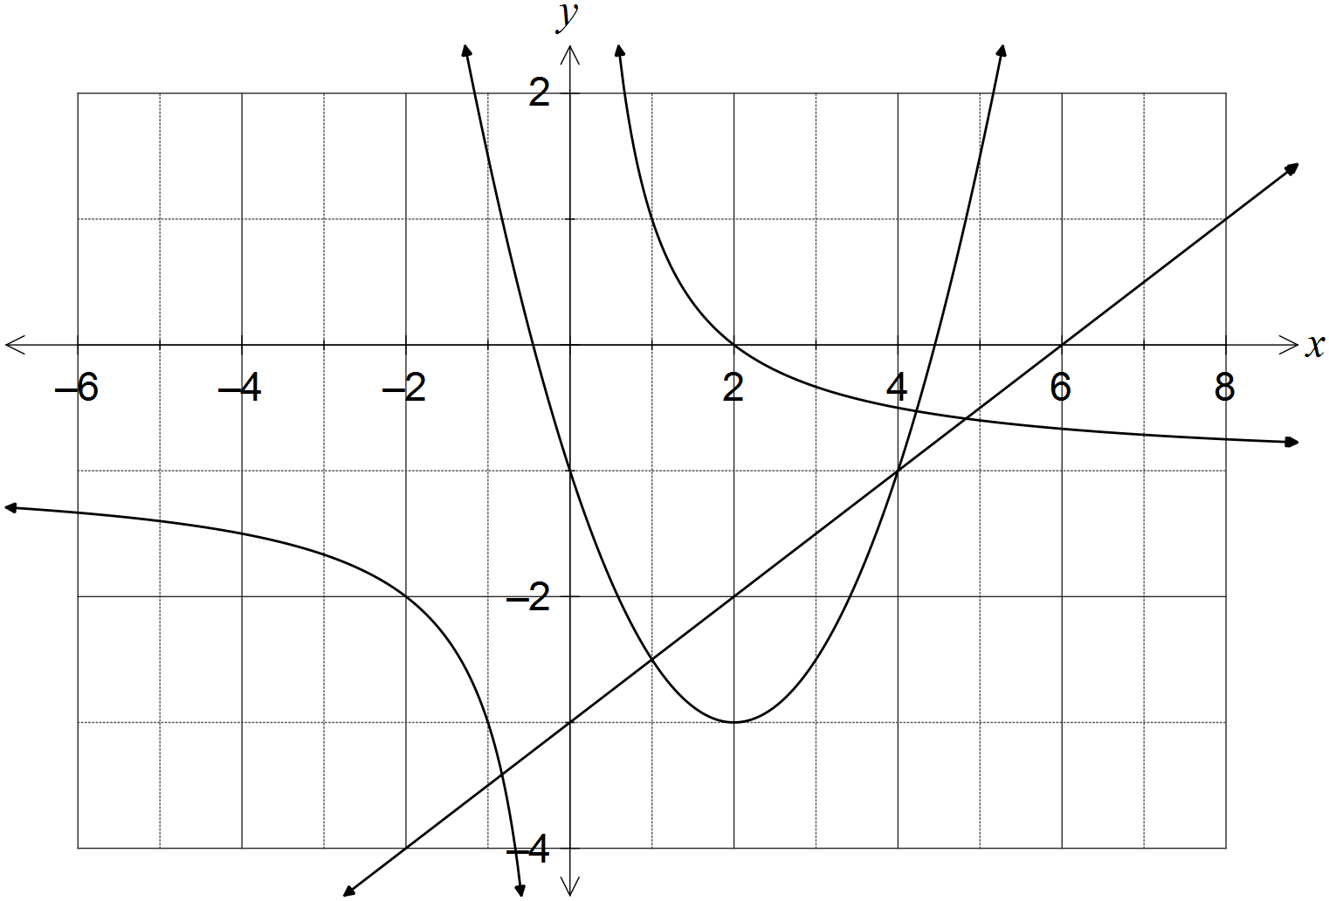

Question 17 (9 marks)

(a) The diagram below shows the five graphs , , ,  and , where a, b, c and d are constants.

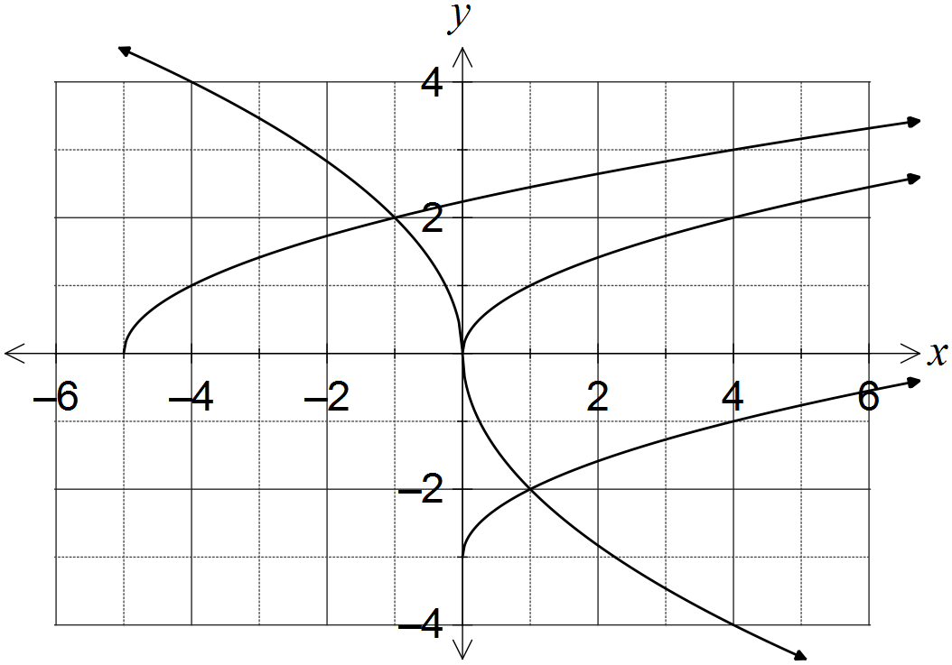

(i) Determine . (1 mark)

(ii) Determine the values of the constants a, b, c and d. (4 marks)

(b) Describe two transformations that will transform the graph of  to:

(i) . (2 marks)

(ii) . (2 marks)

Question 18 (7 marks)

In triangle ABC, ,  cm and  cm.

Determine the largest possible area and smallest possible perimeter of this triangle.

Question 19 (8 marks)

(a) Given that , where , show how to determine the exact value of

(i) . (2 marks)

(ii) . (2 marks)

(iii) . (2 marks)

(b) Determine the two smallest solutions to the equation  for .

(2 marks)

Question 20 (7 marks)

(a) Determine the exact area of a sector enclosed by an arc of length 42 cm in a circle of radius 12 cm. (2 marks)

(b) In the diagram below, BC is a tangent to the circle with diameter AB and centre O.

Given that  cm and  cm, determine the shaded area. (5 marks)

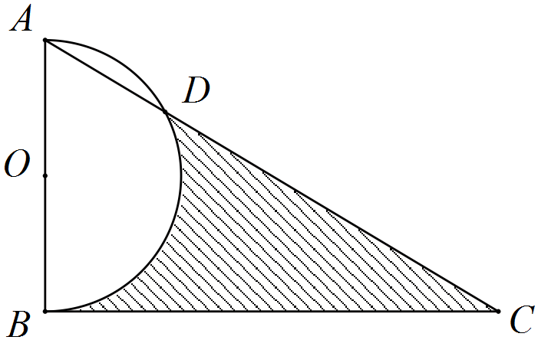

Additional working space

Question number: _________

Additional working space

Question number: _________

Additional working space

Question number: _________

Additional working space

Question number: _________

© 2016 WA Exam Papers. Rossmoyne Senior High School has a non-exclusive licence to copy and communicate this paper for non-commercial, educational use within the school. No other copying, communication or use is permitted without the express written permission of WA Exam Papers.